Project Documentation
Project Title: Enchanted Wings: Marvels of Butterfly Species

Introduction
- Project Title : Enchanted Wings: Marvels of Butterfly Species
- Team ID : LTVIP2025TMID33796
- Team Members :
1.Nimmakuru Ramsai
2.Namburu Venkata Siva Prasanth
3.Nanduri Sai Sravanthi
4.Nandi Vardhan Odugu

Project Overview
The project aims to develop a butterfly species image classifier using deep learning and transfer learning. It uses pre-trained CNNs (like ResNet50, VGG16, or MobileNet) fine-tuned on a dataset of 6,499 images across 75 butterfly species. The goal is to assist researchers, conservationists, and educators by automating butterfly identification to support biodiversity studies and reduce reliance on manual classification.

Key Features
- Upload butterfly image to get species prediction
- High-accuracy model using transfer learning
- Web-based interface with fast inference
- Deployment on Heroku/Render for public access
- Robust performance even in real-world conditions

Architecture

Frontend
- HTML, CSS, JavaScript interface
- Allows users to upload butterfly images
- Displays prediction results and confidence scores

Backend
- Python Flask REST API
- Receives uploaded image, preprocesses it, sends to ML model ● Returns species prediction to frontend

Database (Optional)
- Can be used to log user uploads and predictions for feedback or future analysis
- Storage layer is optional and modular

Setup Instructions

Prerequisites
- Python 3.8+
- Flask
- TensorFlow, Keras
- PIL, OpenCV
- Google Colab or Jupyter Notebook
- Git
- Cloud deployment (Heroku/Render)

Installation
# Clone the repository git clone https://github.com/https://github.com/Butterfly-Innovators/Enchanted-wings-M arvels-of-Butterfly-Species-.git

# Install dependencies pip install -r requirements.txt

# Run Flask app python app.py

Folder Structure
project/
│
├──my_ model/ # Trained model file
├── static/ # For frontend images or styles
├── templates/ # HTML templates
├── app.py # Flask backend
├── utils.py # Image preprocessing functions
├── requirements.txt # Python dependencies
└── README.md # Project overview

Running the Application
- Start Flask App:
python app.py

- Access in browser:
http://localhost:5000/

API Documentation
Endpoint | Method | Description
/ | GET | Home page for image upload
/predict | POST | Upload image and get classification
Request:
● File upload (multipart/form-data)

Response Example:
{
"species": "Papilio demoleus",
"confidence": "92.35%"
}

Authentication
🔒 Not applicable in current version.
This project currently doesn’t include user authentication. Future enhancements may include:
● JWT-based user login for storing prediction history ● Admin panel to manage species database

User Interface
The web interface includes:
- Image upload field
- Button to submit image
- Display of predicted species and confidence ● Clean layout for non-technical users

Testing

Performance Testing
- Accuracy: >90%
- Precision/Recall: ~88%
- Inference time: <1 second
- Tested across varying image qualities

Functional Testing
- Manual UI testing
- Browser compatibility: Chrome, Firefox ● Tested on desktop and mobile devices

Tools Used
- TensorBoard
- Manual test cases
- Google Colab

Screenshots and Demo
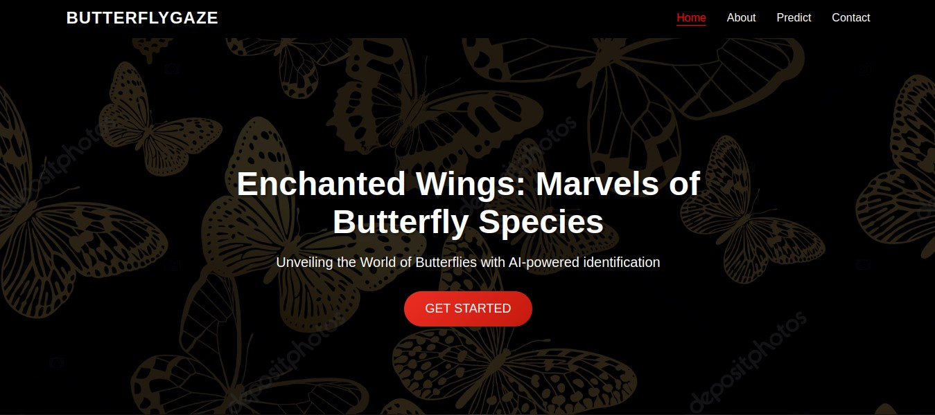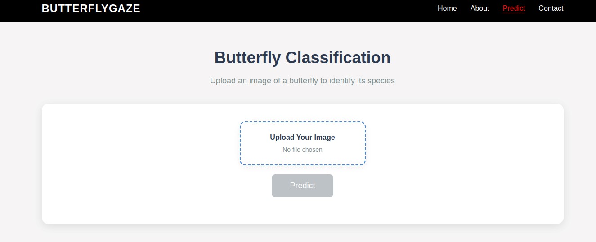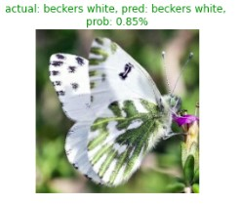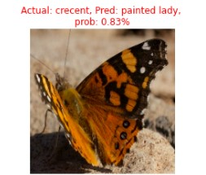

Known Issues
- May misclassify similar species in poor lighting
- Requires GPU for fast training
- Internet required for hosted prediction (no offline mode yet)
- Model performance tied to dataset diversity

Future Enhancements
● Increase dataset size and species coverage

● Convert to mobile app (Android/iOS)
- Add offline prediction (e.g., TensorFlow Lite)
- Add Grad-CAM for explainability
- Multi-language UI

● Real-time camera detection support

